IMP Planner – Strand 3 Build Process: Phase 1

Object
The object of this document is to detail the process of completing the following tabs on the customer ‘Strand 3 Standard Workbook API’, in relation to the Strand 3 first phase of the build process:
- Template, API & Schools
- Grant Database
- Pupils Insert Table
- Funding Statement Check
- Pupils
- Statistics
- Funding

Process

Template, API & Schools
You will be using the workbook AA_NEW – Strand 3 Standard Workbook API, which can be found in Implementations/1.Admin/0.New Customer Build Templates/AA_NEW – Build Templates/AA_NEW – Planner Split Strands API.

Check if the template is the most recent version.
The version number can be found on the ‘Parameters’ tab of the AA_NEW – Strand 3 Standard Workbook API workbook.

Template Prep
Once you have copied the latest version of AA_NEW – Strand 3 Standard Workbook API into the Workbook folder, you will need to update the API key in the Parameters tab using the process notes found in the adjacent Notes tab.

Schools
You will need to update the school information on the ‘Schools’ tab, referring to the ‘Welcome Meeting’ section on the scope, including the LA information and the school type.

Local Authorities
The scope will list how many local authorities there.
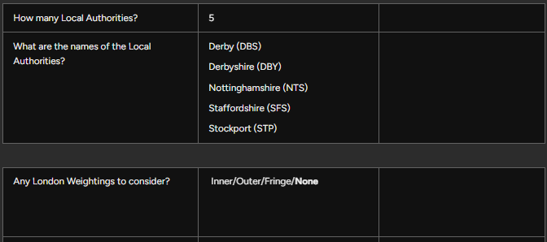
On the tab ‘LocalAuth’, you can view the LAs and their codes:
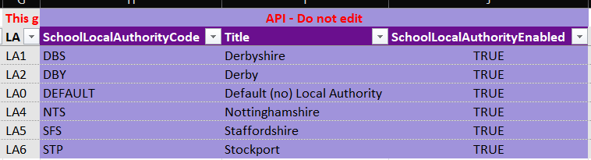
Please check that the LA listed on the ‘Schools’ tab is correct for the relevant school. Any edits can be made on the below section:
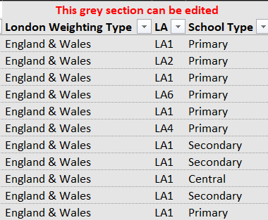
The above section also needs to be edited to reflect whether there are any London weightings.
You can find a full list of schools, their associated LAs and their weightings in: 1.Admin > 1. Standard LA Documentation > Local Authorities - IMP standard codes.

Update the School Type
Amend the ‘School Type’ column as required, referring to the ‘Welcome Meeting’ section of the scope for confirmation.
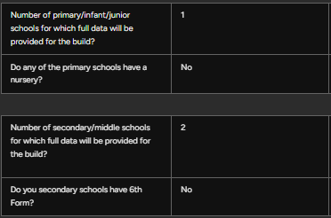

Grant Database

Function
As we use a multitude of grants and calculations, this document keeps all the ESFA grant figures and statistics we require in one place for easy reference. We use the grant database to source the following:
- SCA band and location factor statistics
- Pupil premium numbers
- Pupil premium values (for checking during the review)
- DFC values (for checking during the review)
- UIFSM pupil numbers
- UIFSM values (for checking during the review)

Set Up
This document is located in 3. Data Manipulation Tools folder > AA_NEW Planner Strand 3 > Planner Grant database.
This document will need copying and saving/ pasting into the Manipulated > Strand 3 folder.
Enter the school names, URNs and school codes onto the ‘Schools’ tab. This information can be found on the ‘Schools’ tab of the workbook.
You can then go to Queries and Connections on the spreadsheet, double-click on the ‘Grant Database Source’ option and load up the power query.

Locate the source folder in 3. Data Manipulation Tools folder > AA_NEW Planner Strand 3 > Grant Database Source and import this. The query can then be closed and loaded.
Once completed, right click and refresh on the table on the ‘Summary’ tab. This may take some time to load.

Pupils Insert Table

Function
The purpose of this tab is to enter the raw data from the customer’s census documents/ data, from the funding statements and from the grant database. This data will then be pulled through to the Pupils tab, where the data is further processed and tidied.
The data entered into this tab will then provide the source information for various calculations, for example RPA and Pupil Premium (see document: S3 – 2 – Grants and Calculations). Pupil numbers are fundamental in ensuring IMP calculations are correct.

Census Data
In the file ‘Customer Supplied Data > Strand 3 > Pupil Numbers’, locate the census information. This could be provided via spreadsheet or via census documents. We request as standard: Spring (January) numbers from two years previous and one year previous; Autumn (October) numbers from the previous year, including PLAC & service numbers.
Spring numbers are entered onto finance codes: PUPIL_SPRING_[key stage]. These are entered based on the total number of pupils in that key stage.
Spring numbers are used in DFC, SCA and PE Grant calculations.
Autumn numbers are entered onto finance codes: PUPIL_CEN_[year group]. These are entered individually by year group.
Autumn numbers are used in RPA calculations.
If entering data from census documents, please ensure to check if there are any ‘Subsidiary’ pupils in the relevant column. If there are, these pupils will need to be removed from the total of the key stage/ year group.
With PLAC & service, these are entered onto the finance codes: PUPILPREMIUMPLAC or PUPILPREMIUMSERV. Please note that these are taken from the Autumn census data, and these are not required for Spring census data.
Spring, Autumn, PLAC & service are all entered into the year shown on the data.

High Needs
Information on high needs placements is found on the funding statements.
For Pre 16 funding statements, check Table D.
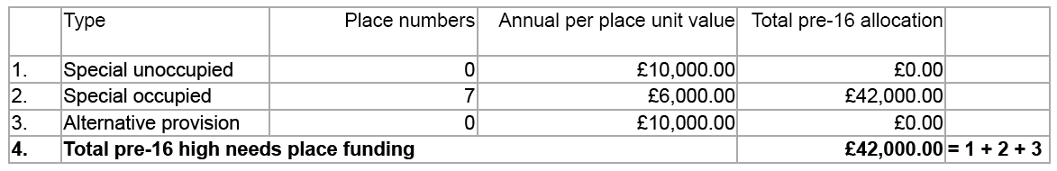
For Post 16 funding statements, check the fourth page.
For both Pre and Post 16, the rates are currently as follows:
Occupied places: £6,000
Unoccupied places: £10,000
Please enter these into the current year on the relevant finance codes.
Pre 16: FUNDED_PPPRE16/ FUNDED_PPPRE16O
Post 16: FUNDED_PPPOST16/ FUNDED_PPPOST16O

Pupil Premium PRI/ SEC
These are located on the grant database. Locate the current year numbers on the grant database and enter these onto finance code: PUPILPREMIUM_PRI/SEC into the previous year.
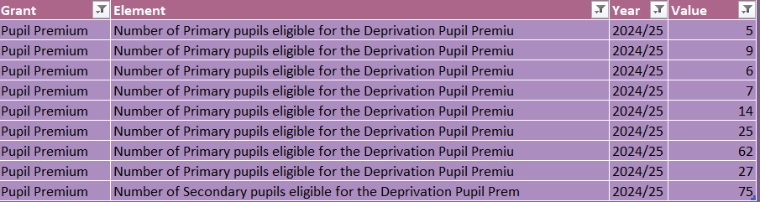

UIFSM
UIFSM numbers are taken from the grant database and are split into January and October numbers. Locate the January numbers for the current year, using the ‘Element’ that begins ‘Total Eligible Meals…’ and includes January census. Take the total of the two lines and add these to the finance code: PUPIL_UIFSM_JAN in the previous year. For example, the total added for the below would be 27.
Repeat this process for October numbers (PUPIL_UIFSM_OCT).

Summary Table of Pupil Data
Finance Code | Description | Year Entered
PUPIL_CEN_[year group] | Autumn census data | The year stated on the data
PUPIL_SPRING_[key stage] | Spring census data | The year stated on the data
PUPILPREMIUMPLAC or PUPILPREMIUMSERV | PLAC/ Service numbers from the Autumn census data | The year stated on the data
PUPIL_UIFSM_JAN/OCT | UIFSM numbers found in the current year on the grant database | Previous year
PUPILPREMIUM_PRI/SEC | Pupil premium numbers found in the current year on the grant database | Previous year
FUNDED_PPPRE16/ FUNDED_PPPRE16O | Pre 16 High Needs pupils from the funding statement (table D) | Current year
FUNDED_PPPOST16/ FUNDED_PPPOST16O | Post 16 High Needs pupils from the funding statement. | Current year
FUNDED_[key stage]_ADJ | Adjustments based on Funding Statement Check | Current year

Funding Statement Check

Function
There can be variances between the funding statement pupil numbers and the actual pupil numbers stated in the census. As the DFE calculations are based on previous year Autumn numbers, we need to confirm what variances there are and then update pupil number adjustment lines (detailed in ‘Pupils’ section’) accordingly. This will then ensure that the funding statement totals that IMP calculates are correct and match the DFE funding.

Updating the Table
Right click and refresh on the table. This will then pull through the previous year Autumn totals (excluding Nursery numbers).
Locate the pupil number totals on the funding statement. For Pre 16, this is on page 3. For Post 16, this is on page 1. Enter these into the relevant columns.
The variances then will show on the right-hand side.
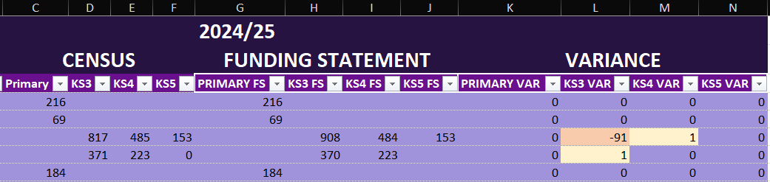
Any variances over 5-10 pupils will likely need flagging to the LC or queried during Priority Queries.
Where adjustments are required, these can be entered either on the Pupil Insert Table tab or directly onto the Pupils tab, it doesn’t matter which. Enter the adjustment onto the finance code: FUNDED_[key stage]_ADJ, switching the signage on the adjustment. For example, the -91 pupils in the above table would be entered as 91 numbers on FUNDED_KS3_ADJ.
Where there are no variances, these lines should be retained as lines and be populated with a zero value.
The adjustment line is sometimes used in ICFP, so this line is best kept in, even if it is not in use in Planner.

Pupils

Function
This tab contains the final version of the pupil data that will be imported into IMP. The ‘Pupil Insert Table’ tab contains the raw data; this data is then pulled through to the Pupils tab, where the data is cleaned, filtered through and trimmed down to ensure only the relevant information is imported.

Values and Checks
On the right hand side, there is a column called ‘Value’. This is the data from the Pupil Insert Table data. Copy and paste all of these values into the ‘YearValue’ column.
Highlight the YearValue column and check that this matches the total values on the Pupil Insert Table tab. If there are any variances, investigate these. You may need to add additional lines – for example, if the customer has provided Spring numbers for next year and the template doesn’t contain these lines, you can copy and paste the existing Spring lines, updating the financial year column. This will then pull through the value in the far right column.

Census Data
Filter for 0 values in the ‘YearValue’ column. The below lines can be removed:
- Blank future year lines
- Blank special places
- Irrelevant year groups or key stages – for example, Post 16 lines where the school does not have a sixth form or Nursery year groups where the school does not have a Nursery.
Filter for ‘SPRING_’ on the finance codes. Where there are values, change the calculated column to ‘FALSE’. Where there are no values, these can remain as calculated ‘TRUE’ and the calculator will pull through Autumn census details in IMP.

Pupil Premium
Keep any 0 values for the current year (and previous years if provided) where the school does not have PLAC or service pupils.
Remove any 0 values for future years if the trust has not provided this data. This is because where lines are left as 0 values, IMP will not calculated future year pupil numbers.

UIFSM
Remove the ‘PUPIL_UIFSM’ finance code lines, as these are only required for simple UIFSM calculations. These are rare, and we build complex calculations as standard.
This should leave just the January and October lines.

Adjustments
Where variances appear on the Funding Statement Check, these can be rectified on the Pupil Insert Table or the Pupils tab.
Enter the adjustment onto the finance code: FUNDED_[key stage]_ADJ, switching the signage on the adjustment. For example, if the variance is -91 pupils on KS3, then this would be entered as 91 numbers on FUNDED_KS3_ADJ.
Where there are no variances, these lines should be retained as lines and be populated with a zero value.
The adjustment line is sometimes used in ICFP, so this line is best kept in, even if it is not in use in Planner.

Statistics

Function
Statistics form part of various calculations in IMP, for example in central charge calculations there is often a top slice percentage required. This would be set up as a statistic in IMP, so that it can be used/ referenced in the central charge calculator, and the customer can amend the value if required in the system.

Template Values
There are many values that are included with the workbook template that do not require amending. These include PFI rates, Teachers Pension Grant rates, ASCL uplifts etc. The technical team currently reviews these rates and updates the template as required with new rates, so the build team does not need to alter these.
You can filter on ‘Will import if 0’ and remove 0 values to view the lines that need updating.

Uplifts
In the scope, the below questions will guide you as to where to look for details on the uplifts required.
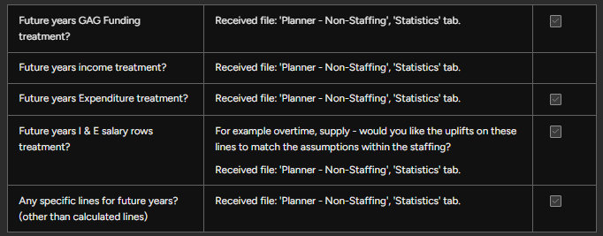
As standard, the template has the below lines:
- UPLIFT_INC
- UPLIFT_EXP
- UPLIFT_GAG
- UPLIFT_POST16
If bespoke statistics are required (i.e. the customer has an 8% uplift for Electricity), new lines can be created and the relevant YearValue entered – see example below.
For bespoke statistics, a new unique finance code per each new statistic will need to be created in ‘Finance Codes S3’ tab.

Central Charge
In the scope, there is a section containing questions on the central charge, where the methodology required should be confirmed.
If a top slice calculation is required, you can enter the top slice value on the finance code ‘CENCHG’.
If a more complex calculation is required, this will need to reviewed and possibly new statistics will need to be created based on the bespoke requirements. Consult your LC if unsure.

SCA
If SCA is required, this will be made clear in the scope (in the section ‘Calculations’). If it is required, you will need to enter the SCA banding rate (‘SCA_BAND_RATE’) and the SCA location rate (‘SCA_LOC_RATE’) from the grant database. These values should be taken from the current year in the grant database and entered into the current year also in Statistics.
If it is not required, all SCA lines can be removed.
Further information about the SCA grant can be found on the SCA Grant document.

AWPU and Lump Sum Values
For each relevant key stage, we will need to enter the AWPU rates and lump sum rates as shown on the funding statement for each local authority.
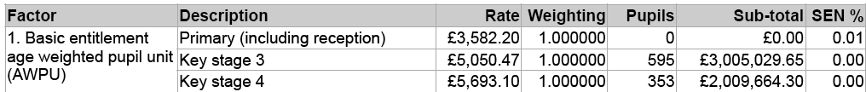
Please note that this will be the rate itself and not the sub-total.
Enter the value, reversing the signage. For example, the Primary AWPU rate above would be entered as -3,582.20.

Special Values
If there is no special school in the trust, you can remove lines that contain ‘SPS’ in the finance code, i.e. ‘DFC_PUPIL_SPS’.

Funding

Function
This tab will populate the ‘Funding’ section in IMP, and contains the following elements:
- DFC funding calculations (lump sum and per pupil calculation)
- UIFSM funding calculations
- PE Grant funding calculations
- SCA funding calculations
- High Needs funding calculations
- Funding statement lines for each school
- Funding statement totals for each school
For the builder, the latter ‘Funding statement lines for each school’ are the only elements that require building in the workbook, as all other lines will be calculated in IMP.

PDF to Excel Conversion
Funding statement documents can be processed through the PDF converter into Excel values. Copy PDF Statements into Input folder in Admin\3. Data Manipulation Tools\PDF to Excel and wait for Output folder to populate with Excel files. When complete, move the Excel files to a new Funding Statement folder in the ‘Manipulated’ folder. Clear down the Input folder ready for the next user.
From Admin\3. Data Manipulation Tools\AA_NEW - Planner Strand 3, copy AA_NEW - Funding Statement Transformer and paste into the customers Manipulated folder and rename accordingly.

Entering Values
Filter by school and then begin entering the values in the YearValue column, ensuring the values are entered as negatives.
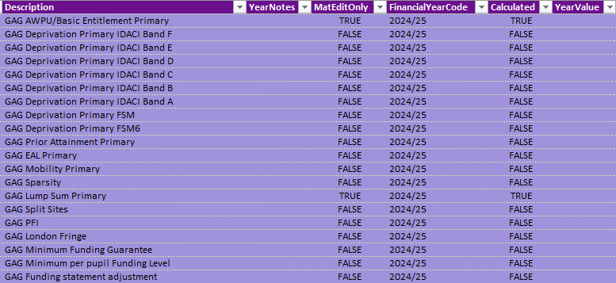
Where there are zero values, these can be entered as zeroes and remain on the Funding tab, as these may be required in future years.
For best practice, the total value for AWPU and lump sum values can be entered, so that it is easier to check the total is correct and matches the funding statement total shown below. These values can then be removed once checked.
Pre 16 - ‘Total school allocation’
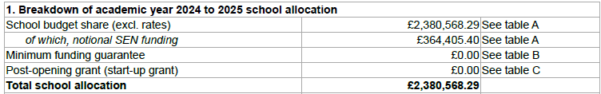
Post 16 – ‘Total funding allocation’
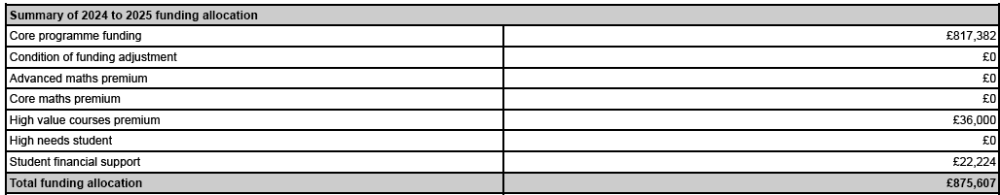
Please note that special places will not be included in this total check, as these will be calculated on separate lines.

Finance Codes
Filter for ‘Will import if 0’ and remove 0 values. Update the AWPU and lump sum finance codes to the correct code based on the school’s LA.
All calculators can be found on the ‘Calculators’ tab, and the LA information can be found on the ‘Schools’ tab. Where there are multiple LAs and school types, it may be easier to create additional columns and use an XLOOKUP to pull through LA information.

Budgets
Next steps for building budgets can be found in the S3 – Workbook – Phase 2 file.

